**Efficacy of Probiotic Mouthwash on Gum Bleeding**

**Results:**

**Participant 1:** Initially, multiple episodes of gum bleeding were observed weekly. Post-intervention, the frequency reduced to three instances.

**Participant 2:** Showed isolated gum bleeding events pre-intervention, which ceased entirely after using the probiotic.

**Participant 3:** Experienced four bleeding events initially, which decreased to two after probiotic use, indicating a reduction but not complete cessation.

**Participant 4:** Recorded consistent weekly bleeding pre-intervention, which was significantly reduced to two episodes post-probiotic.

**Participant 5:** Exhibited occasional gum bleeding initially, with no instances post-intervention.

**Discussion:** The data indicates a general trend of reduced gum bleeding across all participants following probiotic use. While not all participants experienced complete cessation of bleeding, the reduction in frequency suggests potential benefits of probiotics in managing gum health. These findings align with existing literature that supports the role of probiotics in improving oral health parameters.

**Figures and Graphs:** Graphical representations illustrate individual changes in gum bleeding frequency before and after probiotic intervention for each participant. Each participant’s data is marked distinctly to depict changes over the observation period.

**Plot For Participant 1:**

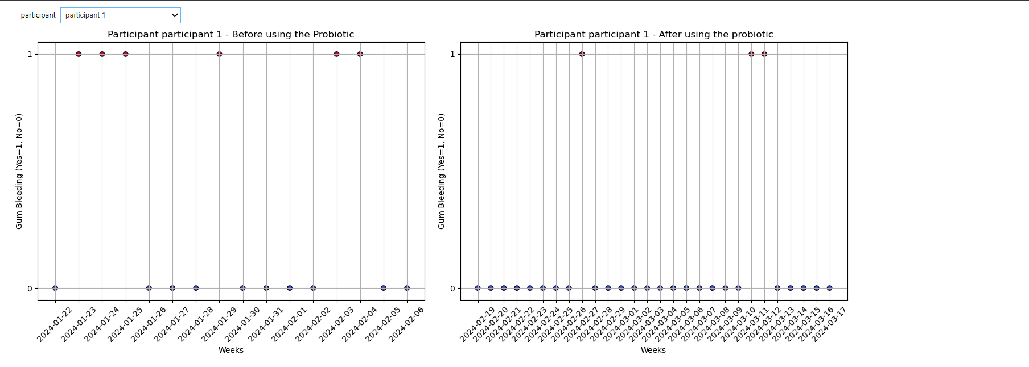Top of Form

**Plot For Participant 2:**

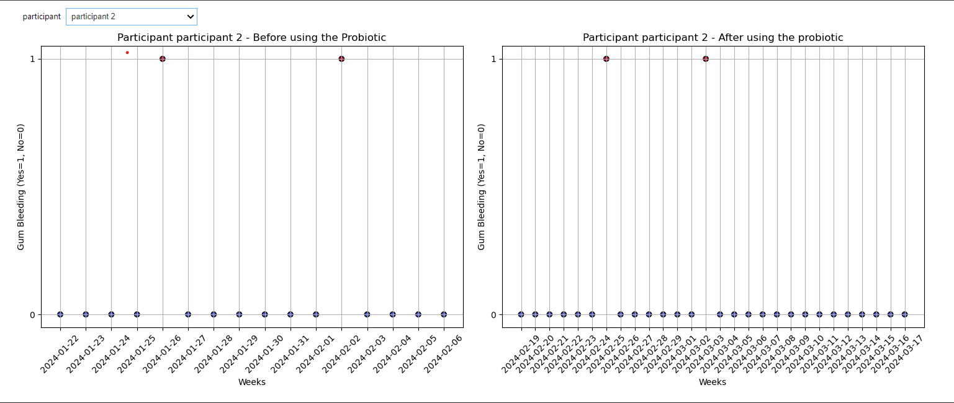

**Plot For Participant 3:**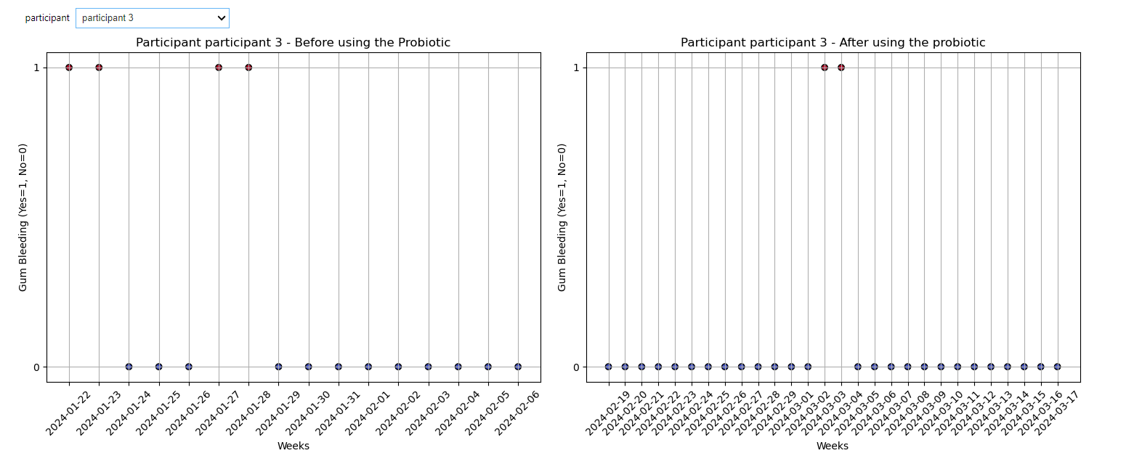

**Plot For Participant 4:**

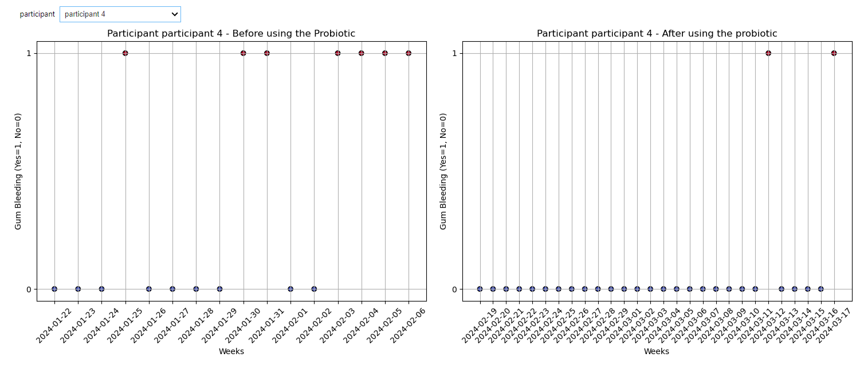

**

**Statistical Results:**

The study recorded the total gum bleeding count and the proportion of days with gum bleeding before and after the introduction of the probiotic mouthwash across five participants. The data are presented as follows:

Table: Gum Bleeding Counts and Proportions Before and After Probiotic Mouthwash Use

**Detailed Findings:**

* **Participant 1:** Showed a decrease in both the total count of gum bleeding incidents and the proportion of days with gum bleeding, from six incidents and 37.5% of days to three incidents and 10.71% of days, respectively.
* **Participant 2:** Experienced complete cessation of gum bleeding post-intervention, with zero incidents compared to two initially, and the proportion of days with bleeding reducing from 12.5% to 0%.
* **Participant 3:** Noticed a reduction in gum bleeding from four to two total incidents, with the proportion of days also reducing from 25% to 7.14%.
* **Participant 4:** Showed significant improvement with a reduction in gum bleeding incidents from seven to two, and the proportion of days with bleeding decreasing from 43.75% to 7.14%.
* **Participant 5:** Also exhibited a cessation of gum bleeding post-intervention, with zero incidents compared to the initial count of two, and the proportion of days with bleeding reduced from 12.5% to 0%.